Kanan Ibadzade

Jarred Chen, Efe Gur Bahadir, Zhi Hao Chong

Centripetal Acceleration

**OBJECTIVE**

1. To calculate the net force on an object moving in Uniform Circular Motion (UCM) and compare to the expected value.
2. Graphically calculate the mass of the object moving in Uniform Circular Motion (UCM) and compare with expected value.

**THEORY**

# A. Mass Rotating in Uniform Circular Motion

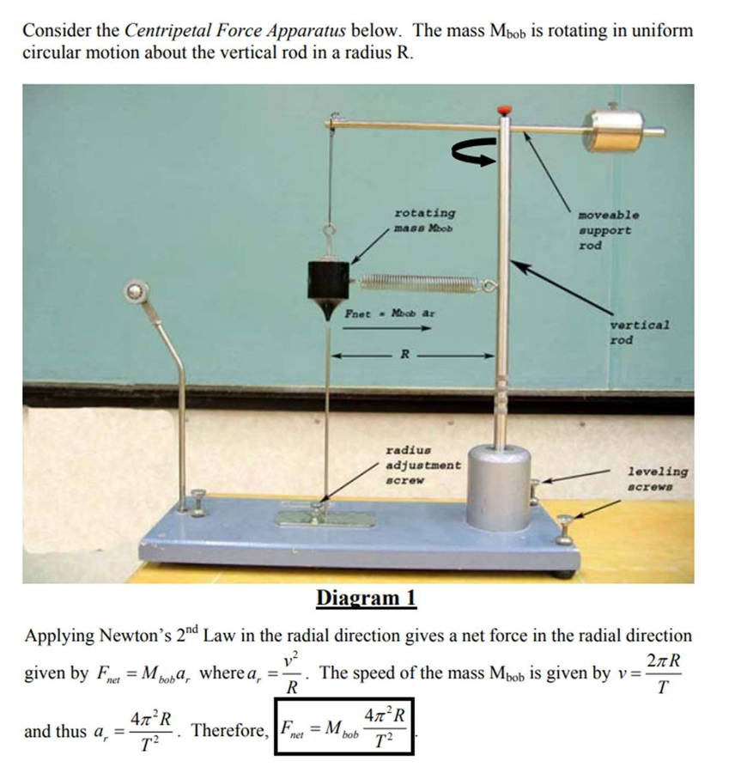

# B. Mass in Equilibrium

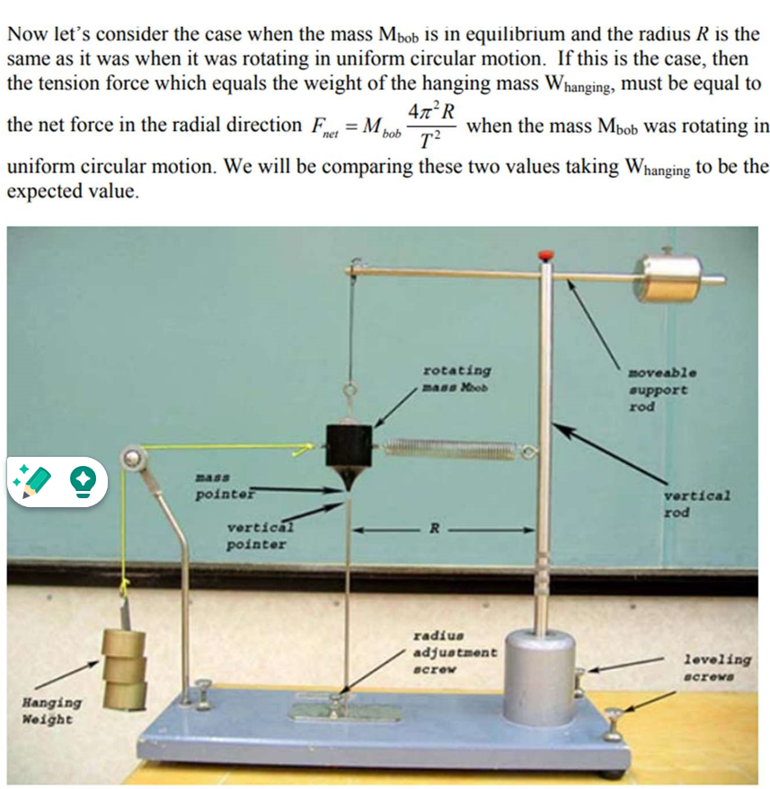

**Diagram 2**

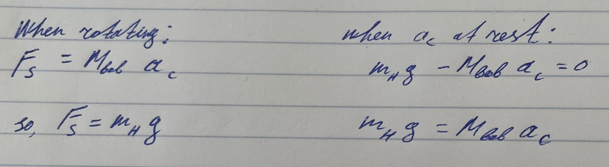

EQUIPMENT

1. centripetal force apparatus

-allow the mass to rotate and simulate a uniform circular motion

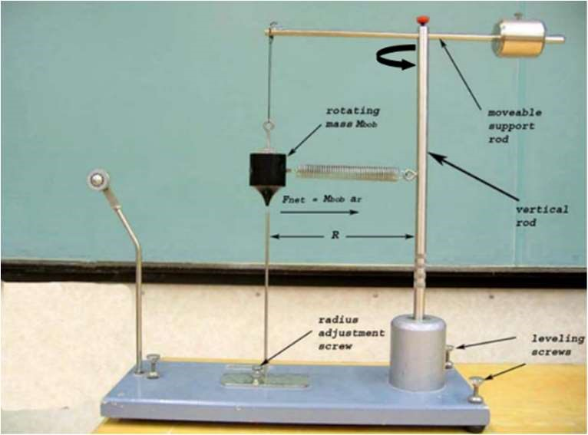

1. set of masses and hanger

-used to determine the net force in the radial direction

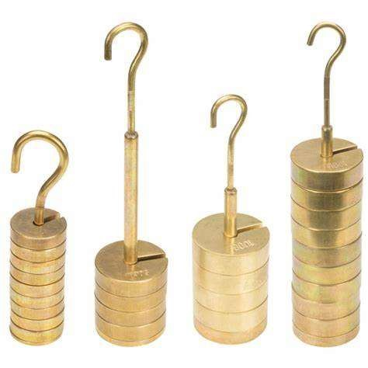

1. stopwatch

-measure the time required to make 10 revs

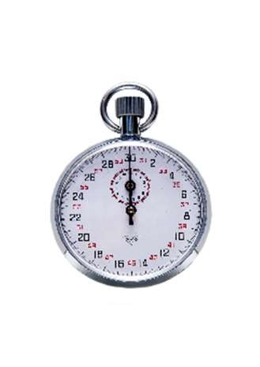

1. string

-connect Mbob to hanging mass



1. level

-ensure the centripetal force apparatus is level

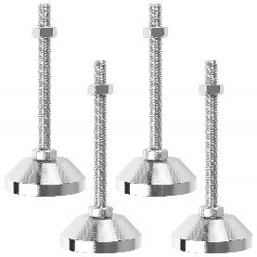

1. ruler

-measure the distance of Mbob from the vertical rod

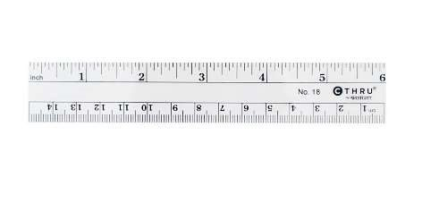

**PROCEDURE**

# Part 1 (Uniform Circular Motion – Diagram 1)

1. Remove mass Mbob from apparatus and measure the mass with triple-beam balance. Place mass Mbob back on the apparatus – but do not attach spring.
2. With the spring not attached, level the platform with the level and align the mass pointer with the vertical pointer.
3. Measure the radius R.
4. Attach spring to mass Mbob.
5. Rotate Mbob at constant speed so that bob pointer is aligned with the vertical pointer.
6. Measure the time for 10 revs 3 times and calculate the average period.
7. Calculate the radial acceleration ar using the average period.
8. Calculate the net force Fnet.

Part 2 (Static Equilibrium – Diagram 2) 1. Leave the spring attached to mass Mbob.

1. Attach string with hanger to mass Mbob.
2. Add mass to hanger until the mass pointer and vertical pointer are aligned just as it was when Mbob was rotating in uniform circular motion.
3. Calculate weight Whanging of hanging mass.
4. Compare Whanging with Fnet. Take Whanging to be the accepted value and use g = 9.80 m/s2.
5. Repeat Part (1) and Part (2) above for a total of 4 different radii.

# Part 3 (Determining Mbob Graphically)

1. Using EXCEL construct a graph with appropriate axis that gives a linear curve whose slope is related to the mass of the bob Mbob.
2. Obtain the equation of the best curve-fit and determine Mbob from the slope of the curve.
3. Compare Mbob to its measured value.

**DATA**

|  |  |  |  |  |  |  |  |  |
| --- | --- | --- | --- | --- | --- | --- | --- | --- |
| R (cm) | Mbob (kg) | t1 (10 revs) | T1 (s) | t2 (10 revs) | T2 (s) | t3 (10 revs) | T3 (s) | Tave (s) |
| 15 | 0.35908 | 6.15 | 0.615 | 6.01 | 0.601 | 6.05 | 0.605 | 0.607 |
| 18 | 0.35908 | 4.76 | 0.476 | 4.13 | 0.413 | 4.81 | 0.481 | 0.457 |
| 21 | 0.35908 | 4.63 | 0.463 | 4.01 | 0.401 | 4.24 | 0.424 | 0.429 |

|  |  |  |  |  |  |
| --- | --- | --- | --- | --- | --- |
| R (cm) | ar (m/s2) | Fs (N) | Mhanging (kg) | Whanging (N) | % error |
| 15 | 16.07 | 5.77 | 0.75103 | 7.36 | 21.6 |
| 18 | 34.03 | 12.2 | 1.25103 | 12.3 | 0.813 |
| 21 | 45.05 | 16.2 | 2.05103 | 20.1 | 19.4 |

1. Pavg2mhg vs. 4π2R

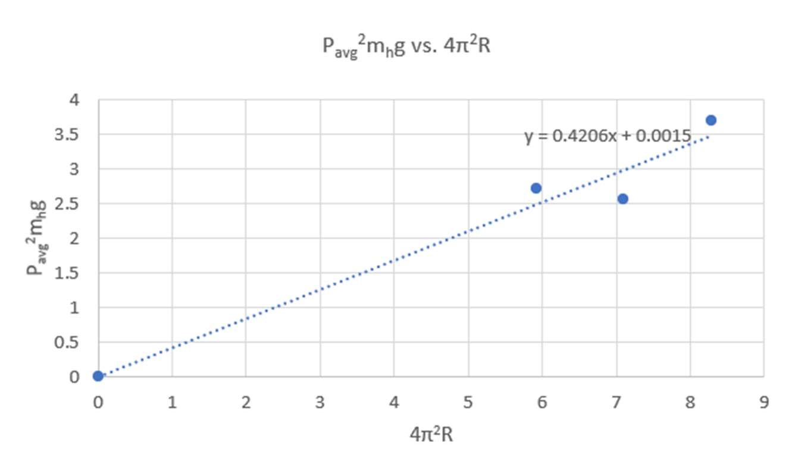

**CALCULATIONS**

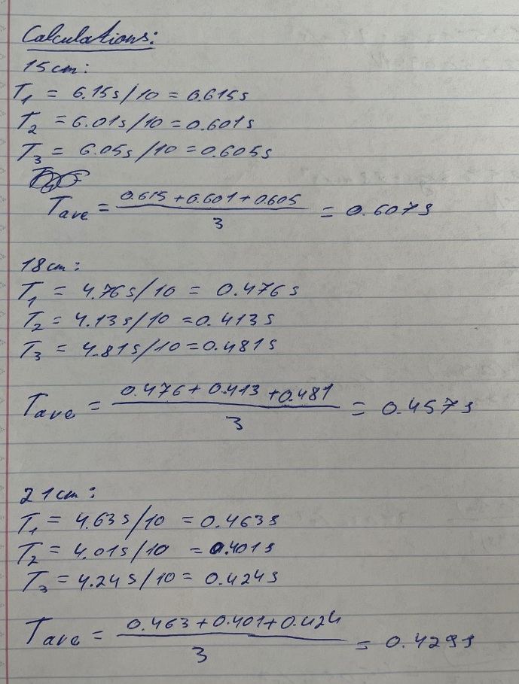

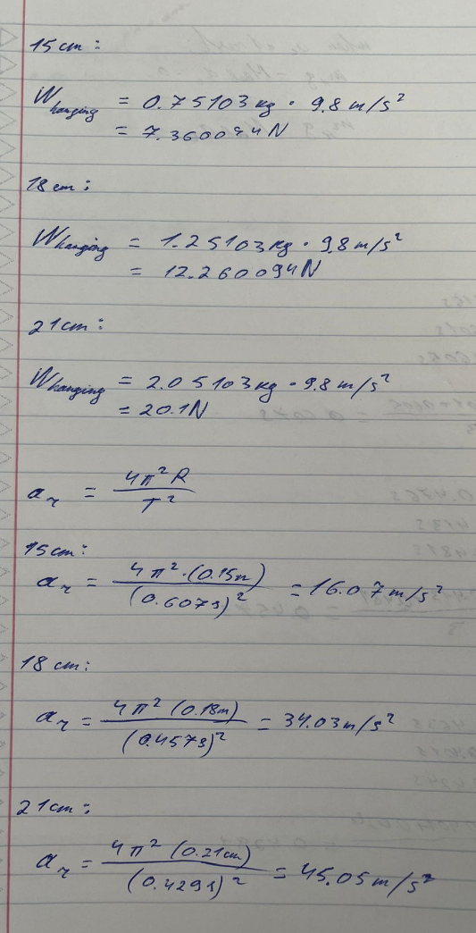

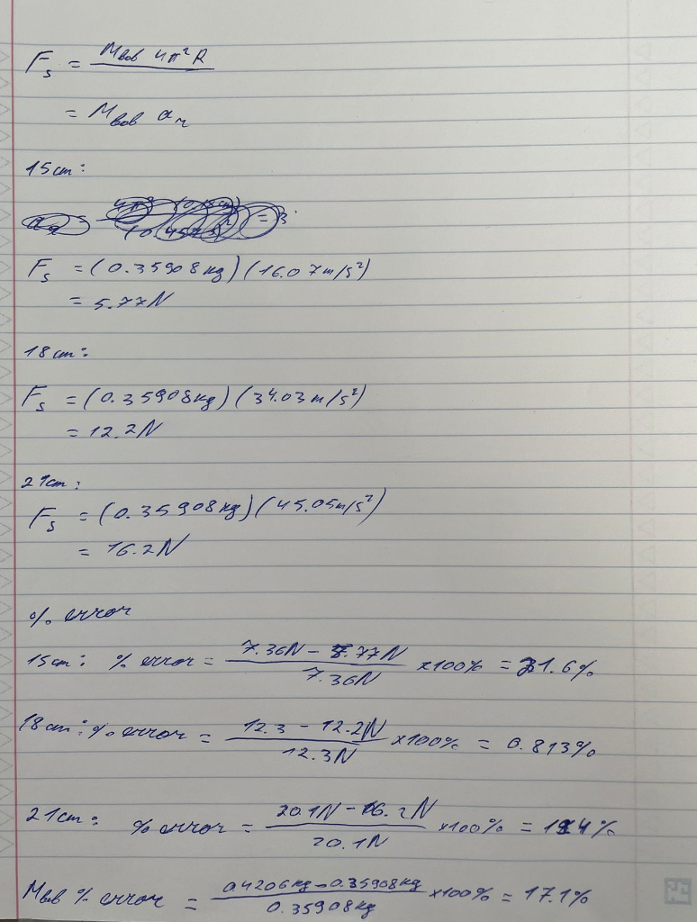

**CONCLUSION & RESULTS**

In this lab, we aimed to calculate and compare the centripetal force acting on an object in Uniform Circular Motion with its expected value, utilizing the equation Fs = (Mbob4π2R)/P2. By analyzing data like the period, radius, and Mbob, we successfully plotted a graph of Pavg2mhg vs. 4π2R, which helped us determine the experimental Mbob from the graph's slope. This method led to the highest percent error of 21.6% at a radius of 15 cm, followed by 21 cm with a 19.4% error, and the lowest at 18 cm with 0.813%. The experiment, conducted under the guidance of the professor and with assistance from lab partners, revealed two significant errors: an unlevel movable support rod, causing systematic errors by affecting the period and thus underestimating acceleration, and air friction, a random error that restricted the rotating mass's movement, leading to a lower calculated centripetal force than the actual value.Начало формы